AI Powered Field Service, Asset Maintenance & Technician Dispatch System
Make.com | Airtable/SmartSuite | OpenAI/Claude | Google Drive | Google Calendar | Google Maps API | Twilio | Slack | Gmail | Google Sheets | Webhooks

Project Overview
Built an automated field service and asset maintenance system for managing equipment faults, technician dispatch, repair operations, and preventive maintenance.
The workflow takes a machine alert or service request and turns it into a complete work order, including fault analysis, risk scoring, technician selection, scheduling, parts management, repair tracking, reporting, and asset health updates.
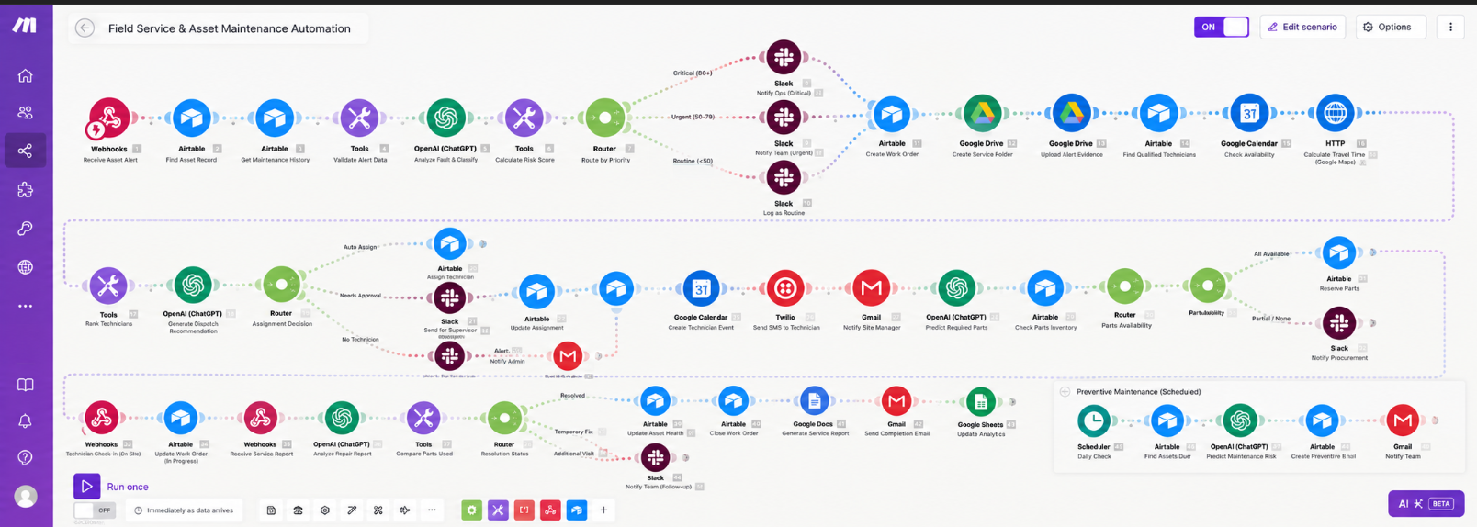
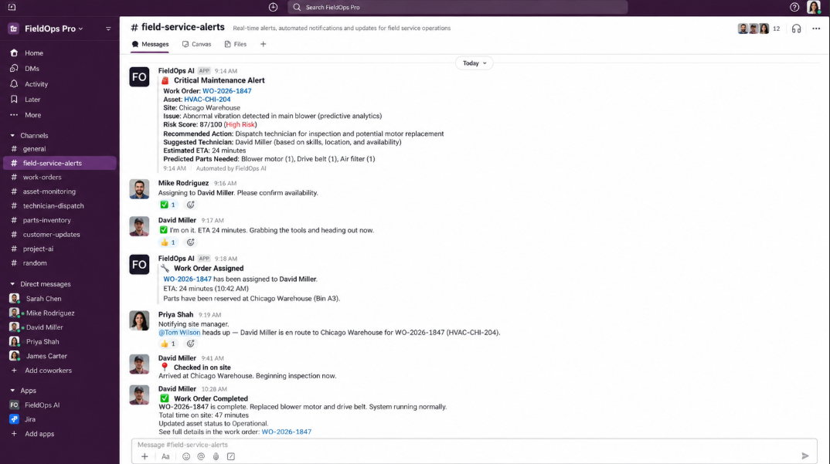
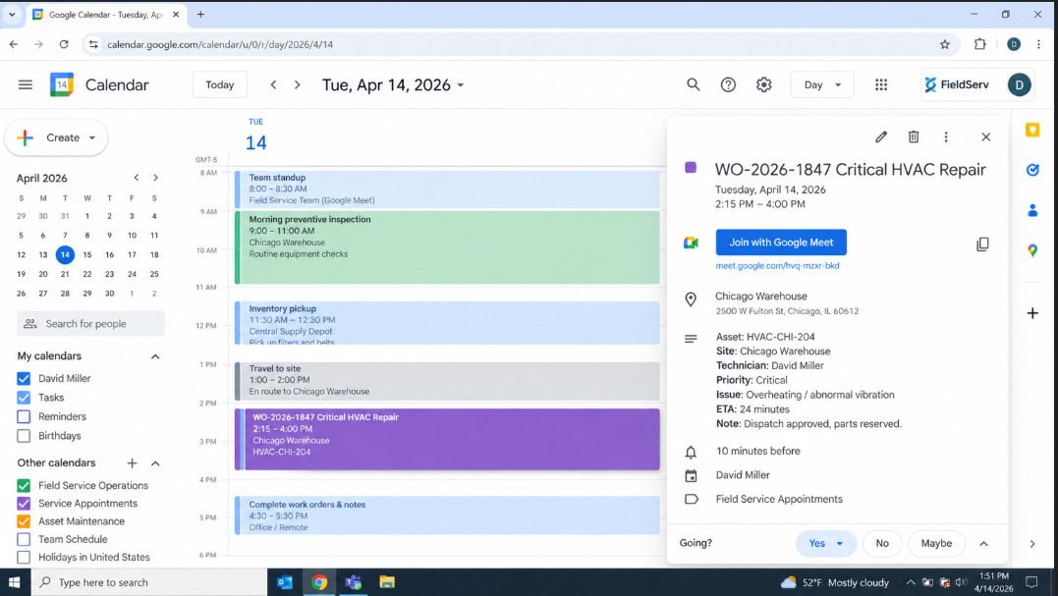
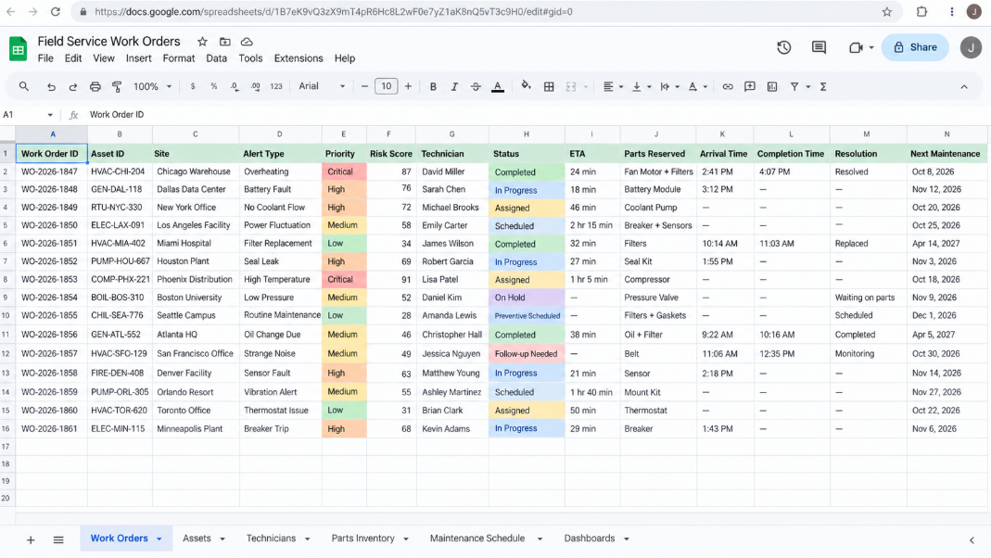

Workflow
The system:
- Receives IoT alerts and maintenance requests through webhooks
- Identifies the affected asset and retrieves maintenance history
- Validates alerts and prevents duplicate work orders
- Analyzes equipment faults and probable causes using AI
- Calculates operational risk and assigns incident priority
- Creates structured work orders automatically
- Creates dedicated Google Drive folders for service records and evidence
- Searches qualified technicians based on skills, region, and certification
- Checks technician availability through Google Calendar
- Calculates travel time and ranks technicians automatically
- Generates AI based dispatch recommendations
- Routes critical jobs for supervisor approval when required
- Assigns technicians and creates service appointments
- Sends technician notifications through SMS and site updates through Gmail
- Predicts required replacement parts and checks inventory availability
- Reserves available parts for the assigned work order
- Tracks technician arrival and repair progress
- Processes technician service reports and repair details
- Generates structured AI repair summaries
- Reconciles reserved and actually used parts
- Updates asset health, service history, and next maintenance date
- Generates final maintenance reports automatically
- Monitors assets for upcoming preventive maintenance
- Creates preventive maintenance work orders for assets at risk
- Updates maintenance and technician performance analytics

Branding & Templates
The workflow uses predefined work order, technician notification, service report, and maintenance templates.
Each template controls:
- Work order information
- Technician dispatch details
- Site notifications
- Service report structure
- Maintenance recommendations
This keeps field service communication and maintenance records consistent across different assets, technicians, and locations.

Content Management
Airtable or SmartSuite acts as the central asset, work order, technician, and maintenance tracking system.
Each work order is updated with:
- Asset information
- Fault category
- Risk score
- Assigned technician
- Parts status
- Repair progress
- Resolution status
- Asset health
- Next maintenance date

Technology
- Make.com
- Airtable/SmartSuite
- OpenAI/Claude
- Google Drive
- Google Calendar
- Google Maps API
- Twilio
- Slack
- Gmail
- Google Sheets
Result
A complete automated field service pipeline that turns an equipment alert into an analyzed, prioritized, assigned, repaired, documented, and completed work order without requiring maintenance teams to manually coordinate every step.
The system also keeps technician schedules, service records, parts usage, asset health, preventive maintenance, and operational analytics organized in one workflow.

